Diacare

Diabetes Prediction & Advisory System



Project ScreenShots
Data Structures Lab

Section: D9

Lab instructor: Hamza Rasheed

Presented By:

Name Registration No
Muhammad Imran Butt L1F24BSCS0546

Muhammad Awais L1F24BSCS0699
Muhammad Zain L1F24BSCS0670

Faculty of Information Technology
University of Central Punjab

- Intro Menu:

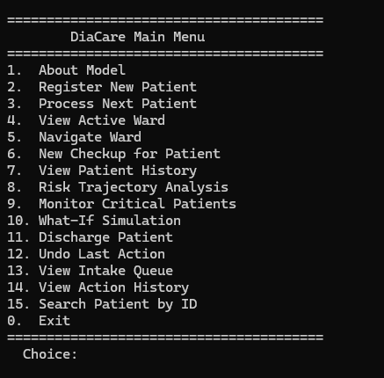

- About Model:

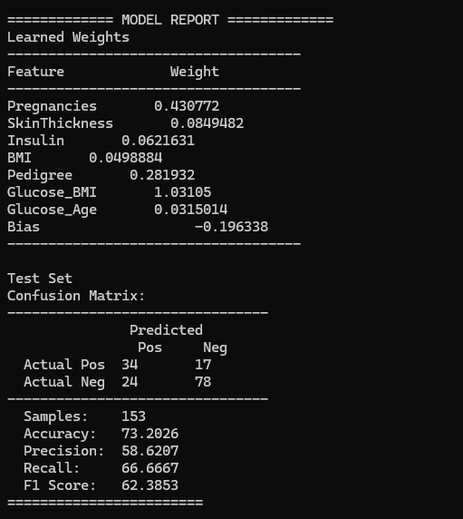
Gfd

- Register Patient

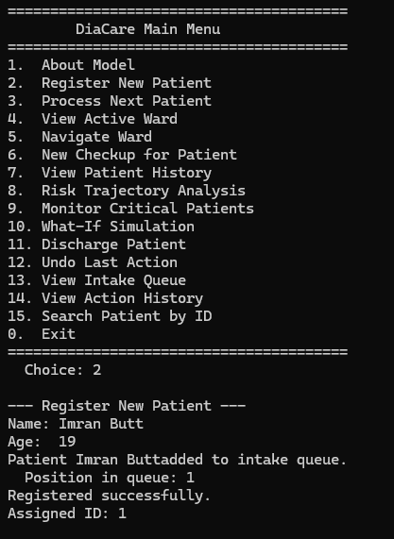

- Intake Queue

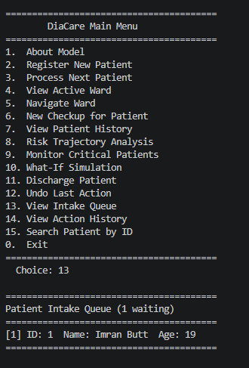

- Process Patient

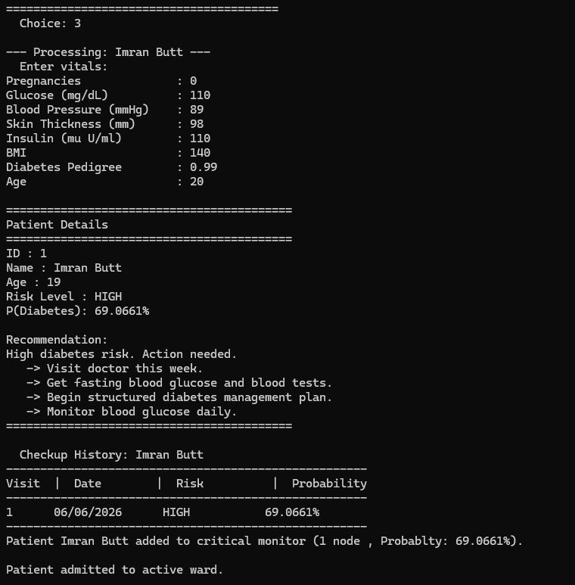

- Active Ward

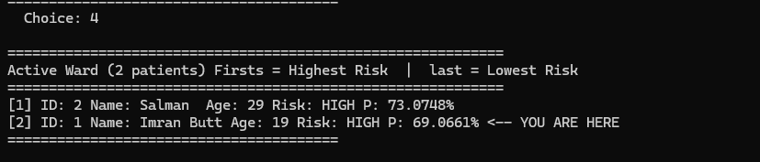

- Navigate Ward (CONTINUED..)

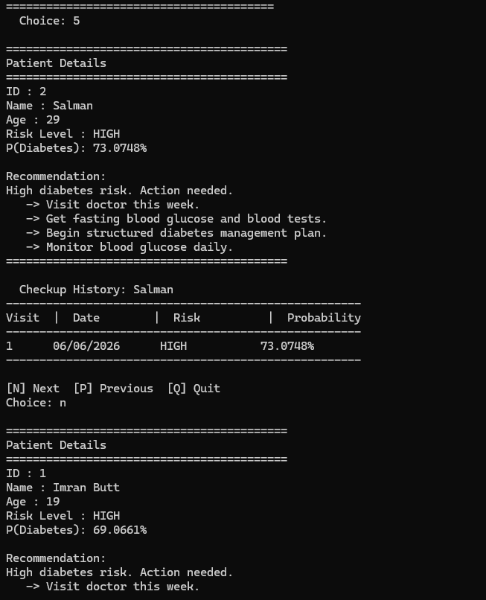

- NAVIGATE Ward

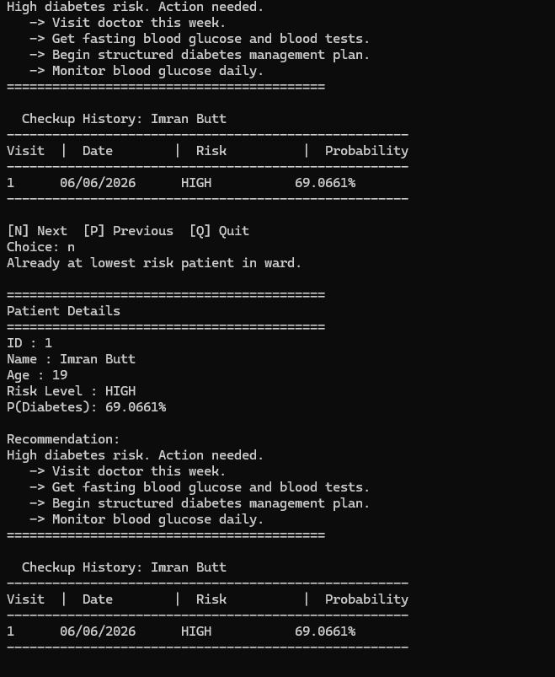

- New Checkup

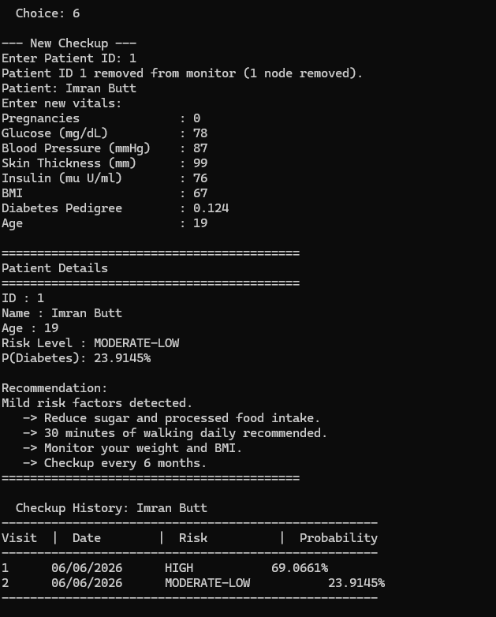

- Patient History

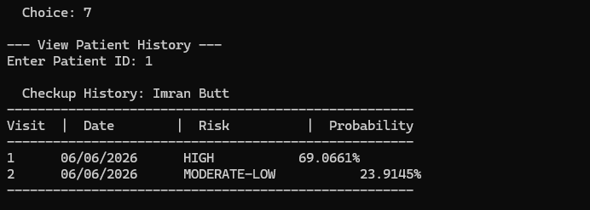

- Risk Trajectory

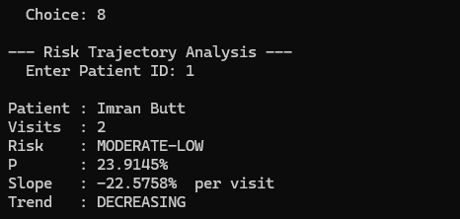

- Critical Monitoring

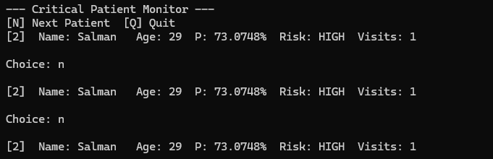

- What if Simulation

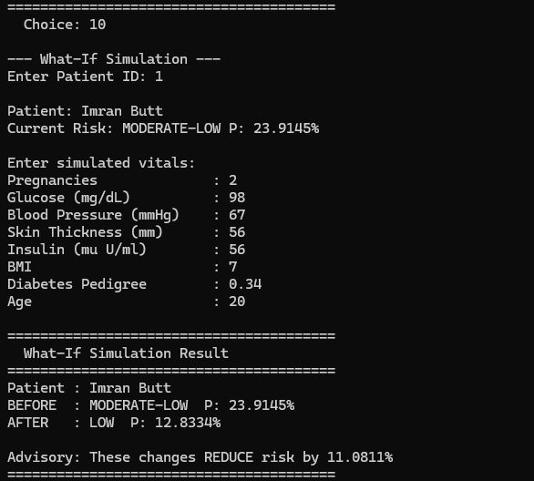

- Discharge Patient

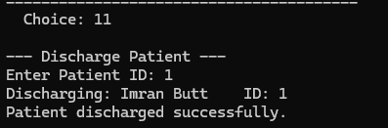

- Undo Action

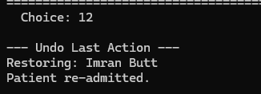

- Active Ward After Undo

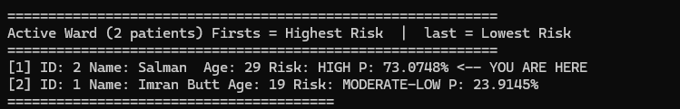

- Action History

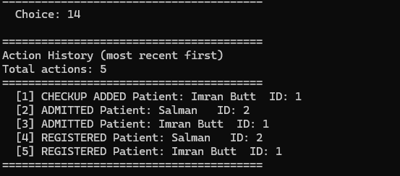

- Search Patient

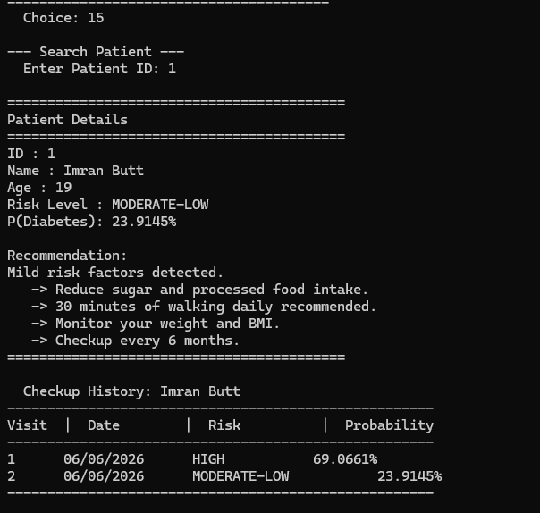

======================== The End ========================

